**Discussion Question: 100 Things**

Using the ***100 Things Every Designer Should Know About People*** reading assignment, select two (2) of the "things" you read about.  In your post, include the number and title of the "thing" (i.e., #36 Time is Relative)  and then do two embellishments, one embellishment, and one visual example, or two visual examples.

1. **Embellish:** Tell us something that the reading did not tell us on that specific "thing" or embellish on what was presented. Be sure you are adding meaningful content to the conversation and not just making noise. Your addition can be a link to an article or you can write out your embellishment.
2. **Visual Example:** Provide us with a graphic example that is relevant to web design. This can be something you create or something you find. Again, be sure to add meaningful content to the conversation.

For this discussion board, my first embellishments are on Topic 62: People Are Motivated By Autonomy. When thinking about the capabilities of a web design, something vital to consider is granting certain access and privileges to users so they can do it themselves. Giving users the option to complete certain tasks gives them autonomy that might get them to return to your site. This article by Shaurya Chhabra provides some ways to increase user autonomy. https://www.onething.design/post/ux-experience-design-to-increase-user-autonomy

An example is offering users the option to change things like subscriptions or other personal information. Providing the option for users to update services instead of dealing with a long, drawn-out process call with a call center can motivate people.

The second topic of embellishment I will focus on is Topic 65: Doing Things Together Bonds People Together. In real-world scenarios, people crave company, and it is the same thing online. If people are not close to each other, then online communication is a way to connect people. Communities can thrive online and find connections that can break into the real world. When creating a website, adding a feature to message other users and friend/follow them can increase the number of times a user goes onto a site. It helps drive traffic from those who are dedicated users. This article by Emily Jones further explains the positive impact on a community through online mediums.

<https://medium.com/@emijones/the-development-of-online-communities-and-social-medias-role-2abd7c113f11>

I included a picture of Facebook’s upcoming events. If fitting for a website, incorporating a spot for users to create and invite others to upcoming events can be beneficial. It further expands the community, and users are encouraged to check back on the site since there are explicit details about the event.

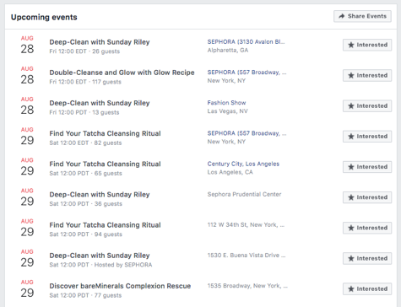

**References**

Chhabra, S. (2024). *UX Experience Design to Increase User Autonomy - Onething Design*. Onething Design. https://www.onething.design/post/ux-experience-design-to-increase-user-autonomy

Jones, E. (2023, August 27). *The Development of Online Communities and Social Media’s Role*. Medium. https://medium.com/@emijones/the-development-of-online-communities-and-social-medias-role-2abd7c113f11

***Before you submit your thread, put your name in the subject line.***

**Assignment Requirements and Grading:**

1. An initial post of approximately 250 words is due by **Thursday, 11:59 p.m. CST**.
2. For the initial post to be considered substantive, it should be at least 250 words in length and fully cover the topics being presented. Single-sentence definitions or responses will not be awarded points.
3. Submit your post by clicking on the **Assignment Link** above, then **Create Thread**. You must create a thread in order to view your peers' posts. Tip: Create your post in a Word document and then copy and paste your work into the thread.
4. A minimum of three (3) responses, **to the original threads of other students**, of 100-200 words each are due by **Sunday, 11:59 p.m., CST**.
5. To view the rubric grading criteria, click on the following link: [Discussion Board Grading Rubric](https://content.bellevue.edu/cst/csd/rubricdbv3.pdf).

**(50 points)**

Samir, you did a lovely job elaborating on topics 64 and 67 for this module. From a buyer’s perspective, I prefer to see items on people. It really does help me envision how the product would look on me. If there are not any product pictures, including a person provided by the business, I often try to find reviews of other people using or wearing it to give me a better idea of whether the product truly is for me. Do you experience something similar to this?

I like your example about face-to-face interviews making it more difficult for someone to deceive someone.

Jessica, you did a fantastic job on your embellishments for both of your chosen topics. It is interesting to consider how often I have mimicked others’ behaviors without realizing it. I also wonder how this has guided and encouraged me in ways I never considered before. I also embellished on topic 65. It truly is impressive how quickly spending time doing activities can bond people. Already having a common interest can be a significant bonding factor for people, and then giving them platforms where these connections can grow and expand with others allows communities to flourish. I think Twitch is a great example!

Arely, I enjoyed reading your post for this module and think you did a great job on your embellishments. You are spot on when you say that doing things together can create a strong sense of identity and belonging. I think it is safe to say that most people seek community and companionship, so finding a group where you feel valued can be monumental for a person’s life and the group itself. It is incredible how much we can pick up when communicating with others, especially in person. Words can take on a new meaning based on delivery, tone, and brain syncing.